A Guide to Uploading to Surrey-i

This document will show the steps you need to take to add each of the different types of webpages to Surrey-i. To do this, you will need to have a Surrey-I account with administrative privileges.

The structure of Surrey-i
Firstly, it is important to understand that Surrey-I includes three main types of webpages which have been highlighted below.
Pages* – these are initially blank WordPress sites, but they must be manually linked to the menu to be found

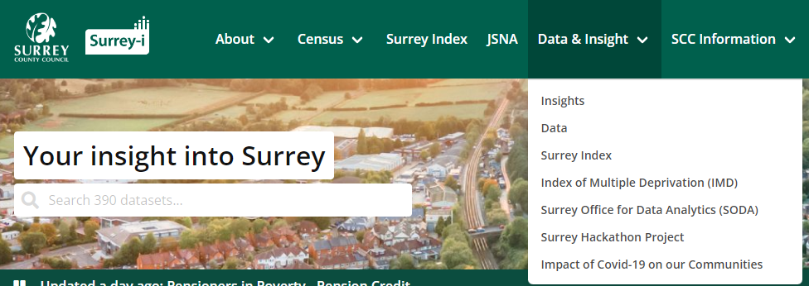
Datasets – these are specific webpages which can include downloadable datasets. These types of webpages have been categorised under ‘Type of Information’ so that they appear in different sections of Surrey-i
Posts – these are initially blank WordPress sites which are automatically included under ‘Insights’ when published

*Please note that Posts can also be linked to the menu.

Datasets are categorised under different Dataset pages under the metadata. The following pages are dataset pages:
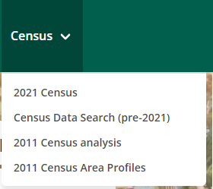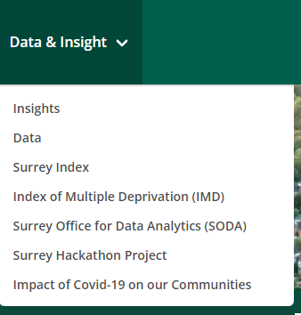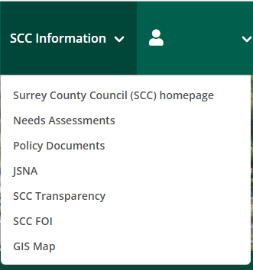

- Making and editing a data page
While pages and posts are quite similar, the data webpages have more of a rigid structure.
You should be able to tell that a page is a Dataset page as it should look something like this at the top: 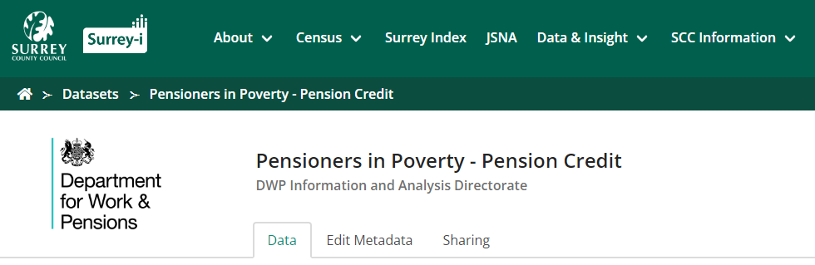
If you just want to do a quick change to a data webpage without it looking like you have added new data – after the changes, click on the ‘update date’ to revert to the old update date.

1a. To make a new Dataset page, go onto go onto one of the pages which list the Dataset pages (this will also show up if you click the search icon) Specifically, when you click on the ‘Data’ under ‘Data & Insight’ option, this page appears:
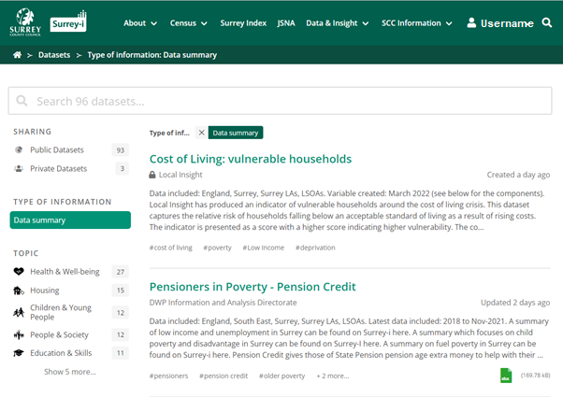
It is important to include hashtags/keywords so that people can find your page
Note that this dataset is set to private to non-admins and therefore has this lock icon

1b. When you are logged in, you should see your username at the right of the screen (‘Username’ in the below screenshot). To add a new data webpage, you can click your name on the top right, and select ‘Add a Dataset’. Please check there isn’t already a version of the information uploaded to Surrey-I by the search function – so that you can add to that page or replace those files rather than making a new dataset webpage. It is easier for users if dataset pages include the various years rather than having them separated.
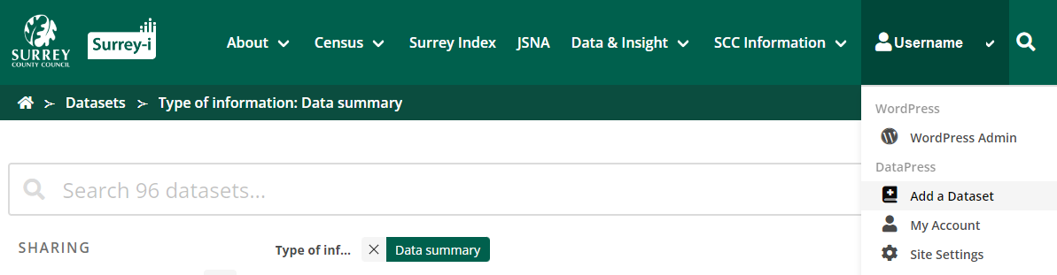

1c. As noted, the way to create a new dataset webpage has specific sections (unlike the page and posts). Before uploading any files, you must fill out the following information: 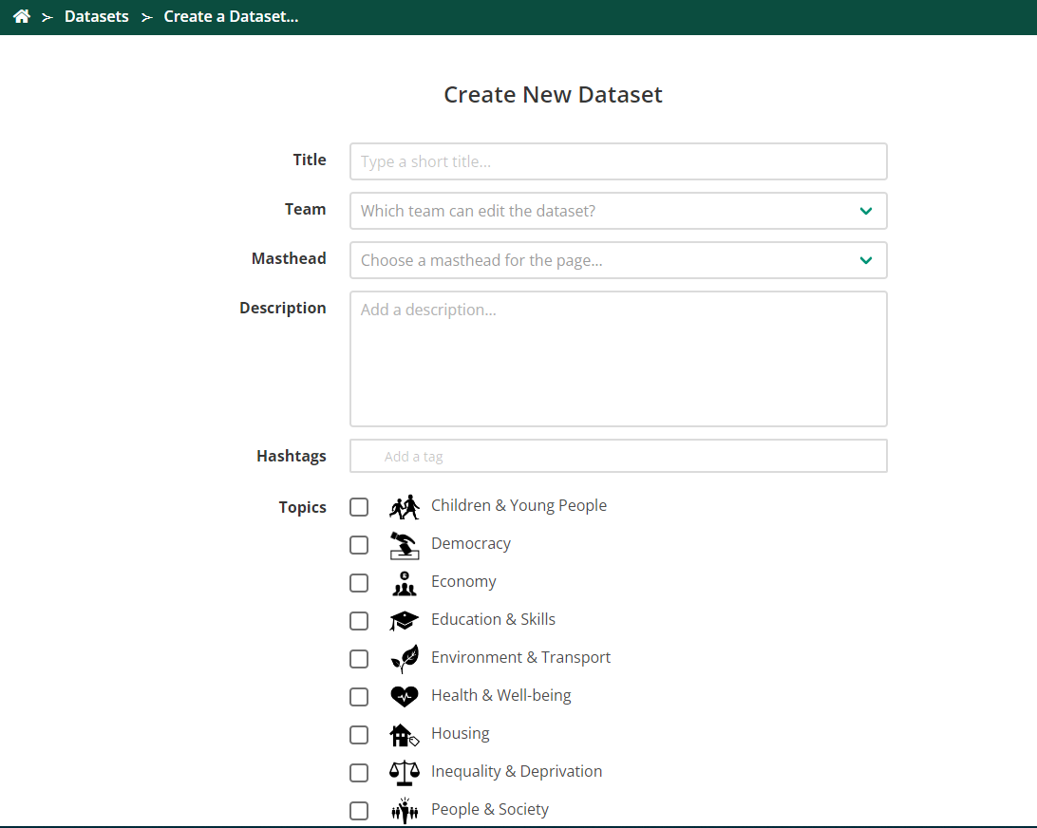
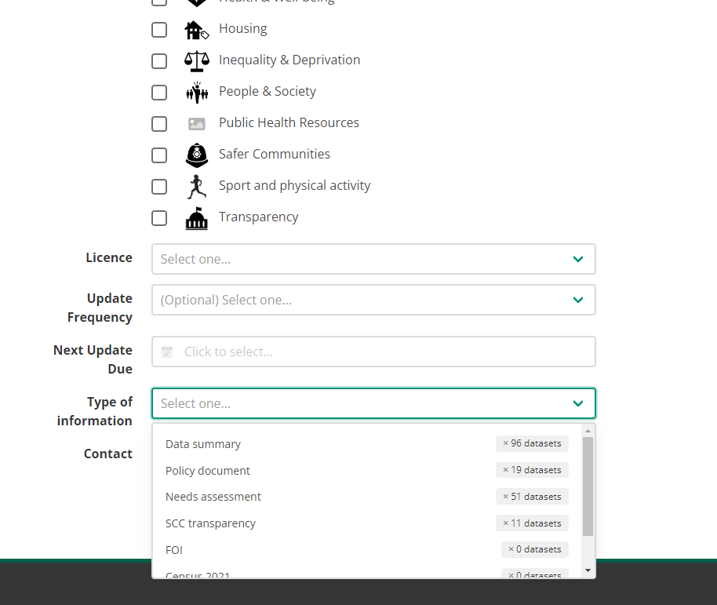
It is VERY important that you select a ‘Type of information’ when you upload a new Dataset page. This is what tells Surrey-I where the Dataset page will appear on the website.
Note that Data summary pages appear under Data & Insight > Data.
Your Dataset page WILL NOT show up on any of these pages without this category (it will, however, be accessed through the search function so do not use this as a way to upload a draft)
Please make sure mastheads and teams are up to date.
In the effort to make the contents of each page clearer, we have started to include the following at the top of each data webpage (in the description section):
Areas included (heading 2 size): e.g. Surrey, Surrey LAs etc.
Dates included (heading 2 size): e.g. 2019/20 (next release December 2022)

Summary (heading 1 size)
Where appropriate, the Population Insight Team has been including a short summary of the latest data on the actual dataset webpage. This is so that the insight into the data can also be accessed by a less technical audience. Images can be included on these pages (for the graphs) but you may need to resize them in the Edit Metadata – Description – unselect Use Visual Editor. This is an example of the code for images with the part about resizing in red/bold:
<p><img src="https://cdn.datapress.cloud/surrey/img/dataset/2nddx/2021-12-16T12%3A48%3A56/Low%20income%20children%20-%20higher%20quality.png" width="600" /></p>

1d. The point of the dataset webpages is to upload versions for interested parties across Surrey. New files are added by selecting ‘+ Add Files…’. A variety of file types can be uploaded to these pages.
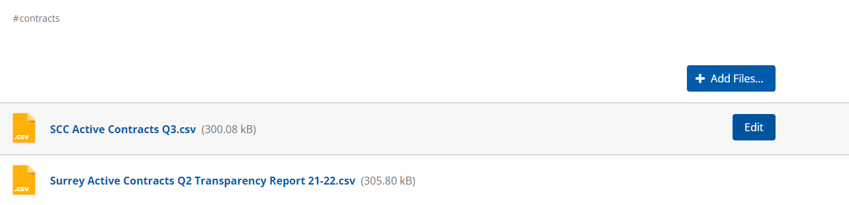

1e. Once a file has been uploaded, you have the option to change the title, replace the file, add notes, and add the time frame of the data. The way that notes appear has been screenshotted below. The ‘Time Frame’ option is sometimes difficult to use – for example, as you need to select months, if your data is per year it can be confusing to add the months.
We recommend using the ‘Add Notes’ function to add the:
dates included (next release date)
& a short description of the file type. I.e. Simple CSV file
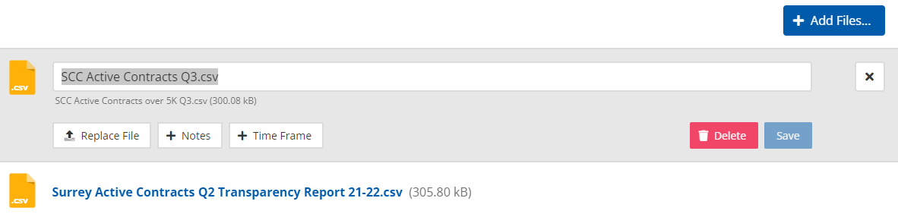

1f. The way that ‘+Notes’ appear below the file is shown below:
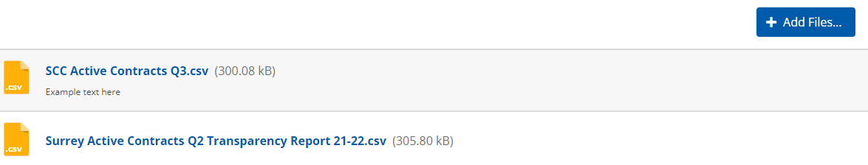
If you just want to do a quick change to a data webpage without it looking like you have added new data – after the changes, click on the ‘update date’ to revert to the old update date.

- Making a new page
Pages are not automatically included on the active website. This section will show you how to make a new page and how to link a page to the menu.
2a. When you are logged in, you should see your username at the right of the screen (‘Username’ in the below screenshot). To add a new page, you need to click your username, it will then show a drop-down menu. You should select ‘WordPress Admin’.
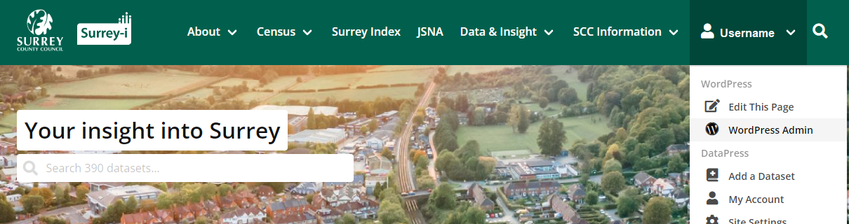

2b. The WordPress Admin should look like the screenshot below. You can add a new page by selecting ‘Pages’ and then ‘Add New’.
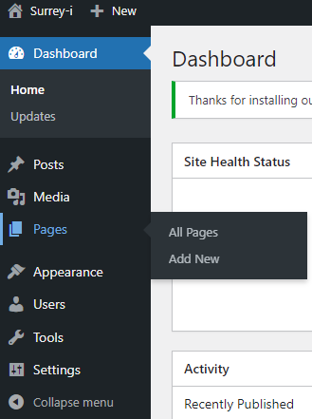

2c. You can also add a new page when on the ‘All Pages’ overview by adding the ‘Add New’ button at the top right.
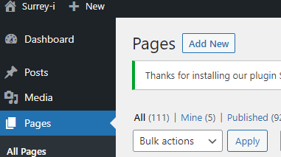

2d. A blank WordPress page should appear – WordPress is highly customisable and there is a large amount of online information on how to use WordPress (including code). Tableau dashboards can be embedded into pages OR posts – the process is included here (i.e. you need to log in to see it).
The author information is included in the settings on the right. If you want to include an author that is not available in the drop-down menu (e.g. SODA), you can scroll to the bottom of the page where you can enter guest author information.
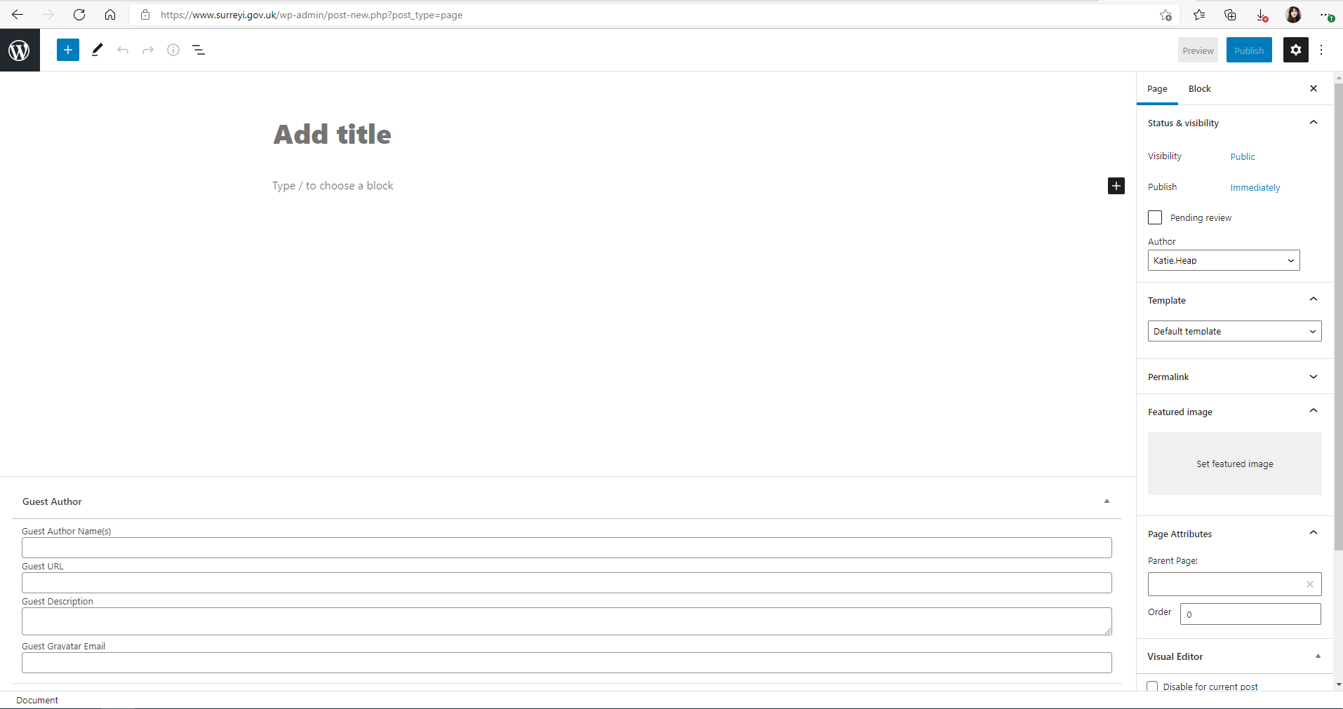
Settings/options panel
Page name
Click to add objects to the page
You can also restore old versions.
2e. Once this page is published, you must add it to the menu or use a hyperlink so that users can find it. To do this, on the WordPress Admin page, select ‘Appearance’ and then ‘Menus’. 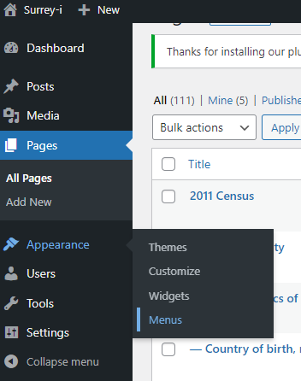
2f. Select the Page you want to add to the menu and then click ‘Add to Menu’.
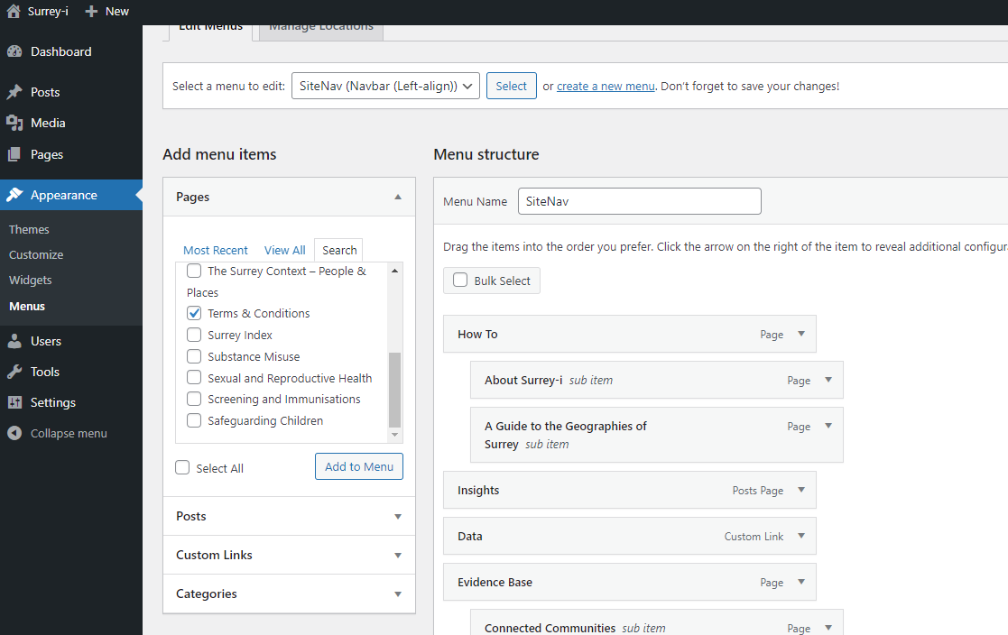
2g. The new page will be added to the bottom of the menu, and you need expand the section and click the options under ‘Move’. Select ‘Under <example name>’ to make it a subpage.
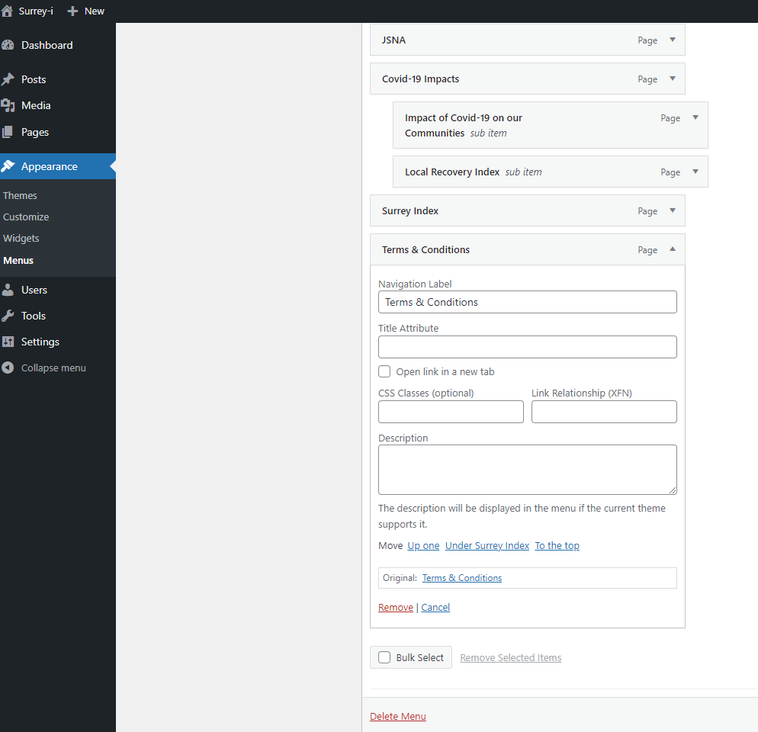

- Making a new post
3a. As noted above, posts are automatically included on the active website under the ‘Insights’ section on the menu. This section will show you how to make a new post.
3b. When you are logged in, you should see your username at the right of the screen (‘Username’ in the below screenshot). To add a new post, you need to click your username, it will then show a drop-down menu. You should select ‘WordPress Admin’.

3c. You can add a new post on the WordPress Admin page and selecting ‘Posts’ and ‘Add New’.
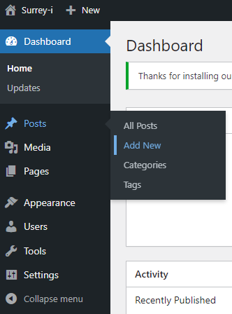
3c. A blank WordPress post should appear – WordPress is highly customisable and there is a large amount of online information on how to use WordPress (including code). The new post page looks the same as the new page option. Tableau dashboards can be embedded into pages OR posts – the process is included here (i.e. you need to log in to see it).
The author information is included in the settings on the right. If you want to include an author that is not available in the drop-down menu (e.g. SODA), you can scroll to the bottom of the page where you can enter guest author information.
Add an image related to your post here – these are shown on the Insights page
Settings/options panel
Post name
Click to add objects to the post
You can also restore old versions.

3d. Here is what the Insights webpage looks like. Posts will be automatically added to this Insights webpage after being published, they do not need to be manually added to the Insights webpage.
Note that the test version did not have a ‘Featured Image’ and so automatically includes this picture. Edits can be made on individual posts after opening them and selecting ‘Edit this Page’ under your name on the right.
