 | 
Local Insight England Summary Report  Epsom and Ewell  Surrey County Council  1 October 2024 | 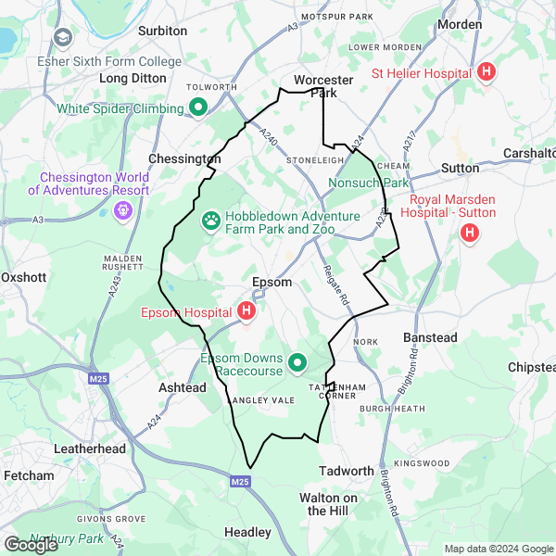

Local Insight
Local Insight provides instant access to the information you need for the neighbourhoods you care about.
We bring together small-area social and demographic data in one easy to use and intuitive platform. You can explore data for any area you are interested in through maps, dashboards and reports.
Find out more at: localinsight.org

OCSI
We combine expertise in research and technology to support organisations working for social good to make evidence-based decisions. We have worked with more than 250 public and community sector organisations from local to international level.
Our research and services are based on unrivalled knowledge and use of place-based social, economic and demographic data.
Find out more at: ocsi.uk

About the indicators
OCSI routinely collect all small-area data published by more than 50 government agencies and other reputable bodies. We identify key indicators relevant to local authorities, grantmakers and charities to include within this report and the Local Insight platform.
We manage and maintain all the data and provide comprehensive metadata so that you can be confident you are using the most up-to-date data.

How we have identified the area of Epsom and Ewell
This report is based on the “Epsom and Ewell” area created by Surrey County Council. There is a map image of the area at the start of this report. Source: Office for National Statistics licensed under the Open Government Licence v.3.0. Contains OS data © Crown copyright and database right [2024].
We use sophisticated aggregation and apportioning methods to calculate the data values used in the charts and tables in this report.
Alongside data for the “Epsom and Ewell” area, we also display data for the selected comparator areas: Surrey and South East.

Contents
Population
Unemployment
Housing
Crime
Health
Education
Employment
Communities and Environment
Access and Transport
Appendix: Data sources

Population
The following data is a summary of key population demographics.
The table below provides an overview of people living in Epsom and Ewell. These population figures provide detail of the structure of the population by broad age bands and by sex. Finally, it also includes a measure of population density by hectare.
The total population of Epsom and Ewell was 80,938 people in 2021.
Of the total population in Epsom and Ewell in 2021, 20.18% are children aged under 16, 61.76% are adults aged 16-64, and 18.06% are over 65 years old.

Population overview
Indicator | Epsom and Ewell |  | Surrey |  | South East
 | Count | Rate | Count | Rate | Count | Rate
All people (Census 2021) (2021) | 80,938 | - | 1,203,108 | - | 9,278,065 | -
All Females (Census 2021) (2021) | 41,736 | 51.57% | 616,067 | 51.21% | 4,738,825 | 51.08%
All Males (Census 2021) (2021) | 39,202 | 48.43% | 587,041 | 48.79% | 4,539,240 | 48.92%
Population aged under 16 (Census 2021) (2021) | 16,331 | 20.18% | 230,595 | 19.17% | 1,723,481 | 18.58%
Population aged 16 to 64 (Census 2021) (2021) | 49,991 | 61.76% | 745,323 | 61.95% | 5,750,327 | 61.98%
Population aged 65+ (Census 2021) (2021) | 14,616 | 18.06% | 227,190 | 18.88% | 1,804,258 | 19.45%
Population Density (Persons per sq km) (Census 2021) (2021) | 80,938 | 2,375.39 | 1,203,108 | 720.40 | 9,278,065 | 486.14
Source: UK Census

Index of Multiple Deprivation (IMD)

The following visualisations draw upon data from the Index of Multiple Deprivation (IMD) to give insight into vulnerable populations in Epsom and Ewell, Surrey, South East. The Indices of Deprivation 2019 are a relative measure of deprivation for small areas (Lower-layer Super Output Areas) across England. The overall Index of Multiple Deprivation 2019 combines together indicators under seven different domains of deprivation: Income Deprivation; Employment Deprivation; Education Skills and Training Deprivation; Health Deprivation and Disability; Crime; Barriers to Housing and Services and Living Environment Deprivation. A higher score indicates that an area is experiencing high levels of deprivation.
The table below shows the IMD score and rank (average LSOA Rank, where a lower rank indicates that an area is experiencing high levels of deprivation) for Epsom and Ewell, Surrey and South East.
Epsom and Ewell has an IMD score of 8.83. This means that Epsom and Ewell has lower levels of deprivation to Surrey (10.08) and lower levels of deprivation to South East (15.55).

Index of Multiple Deprivation (IMD)
Indicator | Epsom and Ewell | Surrey | South East
Index of Multiple Deprivation 2019 (IMD) Score (2019) | 8.83 | 10.08 | 15.55
Index of Multiple Deprivation (IMD) 2019 Rank (2019) | 26,497 | 24,931 | 20,519
Source: Ministry of Housing Communities and Local Government (MHCLG) 2019

The bar chart below explores this further, showing the proportion of people living in neighbourhoods grouped into deciles according to level of deprivation derived from the IMD. A higher score on the IMD indicates that an area is experiencing greater levels of deprivation. To clarify, all neighbourhoods in England are grouped into ten equal sized groups “deciles”; neighbourhoods in decile 1 fall within the most deprived 10% of neighbourhoods nationally, whilst neighbourhoods in decile 10 fall within the least deprived 10% of neighbourhoods nationally.

Proportion of people in each deprivation decile
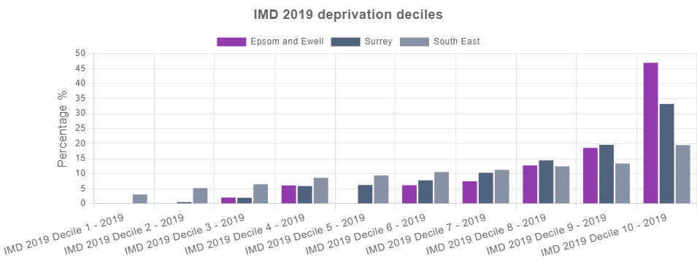
Source: Ministry of Housing Communities and Local Government (MHCLG) 2019

Unemployment
The following data shows the key unemployment indicators.
The table below shows the total number and proportion of people receiving Universal Credit (UC) or Job Seekers Allowance (JSA) by age and sex. The proportion of working age people receiving benefits for unemployment in Epsom and Ewell was 2.24% in Aug-2024. This is lower than the average across Surrey (2.37%) and lower than the average across South East (3.23%).

Unemployment Benefit Claimants
Indicator | Epsom and Ewell |  | Surrey |  | South East
 | Count | Rate | Count | Rate | Count | Rate
Unemployment benefit claimants (Jobseekers Allowance and out of work Universal Credit claimants) (Aug-2024) | 1,115 | 2.24% | 17,780 | 2.37% | 186,900 | 3.23%
Youth unemployment (18-24 receiving JSA or Universal Credit) (Aug-2024) | 145 | 2.71% | 2,465 | 2.75% | 28,955 | 4.05%
Older person unemployment (50+ receiving JSA or Universal Credit) (Aug-2024) | 280 | 0.91% | 4,685 | 0.98% | 45,860 | 1.24%
Unemployment benefit (JSA and Universal Credit), female (Aug-2024) | 575 | 2.24% | 8,785 | 2.31% | 88,565 | 3.02%
Unemployment benefit (JSA and Universal Credit), male (Aug-2024) | 545 | 2.25% | 8,995 | 2.44% | 98,335 | 3.45%
Source: Department for Work and Pensions (DWP)

The chart below shows the total proportion of people receiving unemployment benefit (JSA or Universal Credit) between Jan-2020 and Aug-2024.
The total unemployment rate in Epsom and Ewell has increased from 1.13% in Jan-2020 to 2.24% in Aug-2024.

Unemployment Benefit Claimants (time series)
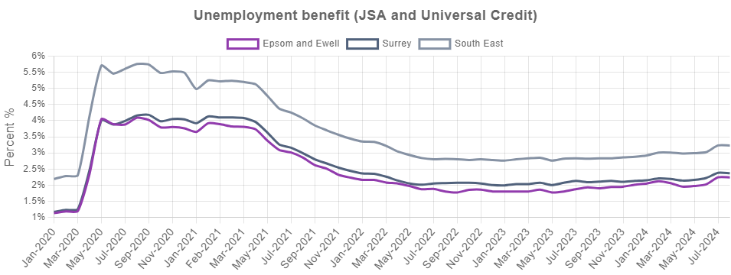
Source: Department for Work and Pensions (DWP)

Housing
The following data is a summary of key housing related indicators.
The table below shows the mean house prices by accommodation type across Epsom and Ewell and the comparator areas for four key dwelling types (flats, semi-detached houses, terraced houses and detached houses) from Jun-2023 to May-2024.
The average property price for all dwelling types in Epsom and Ewell is £580,895, this is lower than the average across Surrey (£628,288) and higher than the average across South East (£448,045).
Data on house prices is from the Land Registry open data price-paid dataset Please note some small areas may not have had a transaction recorded within the twelve month period leading to gaps in the table below.

Average house prices
Indicator | Epsom and Ewell | Surrey | South East
Average house price (12 months) (Jun-2023 to May-2024) | £580,895 | £628,288 | £448,045
Average house price for detached houses (12 months) (Jun-2023 to May-2024) | £912,350 | £1,052,811 | £730,444
Average house price for flats (12 months) (Jun-2023 to May-2024) | £315,655 | £302,529 | £240,611
Average house price for semi-detached houses (12 months) (Jun-2023 to May-2024) | £633,214 | £562,867 | £432,687
Average house price for terraced houses (12 months) (Jun-2023 to May-2024) | £502,174 | £462,614 | £350,238
Source: UK Land Registry

The chart below shows the tenure of housing in Epsom and Ewell, Surrey, and South East.
Tenure types include;
- ‘Owner occupied’ housing includes accommodation that is either owned outright, owned with a mortgage or loan, or shared ownership (paying part rent and part mortgage).
- ‘Social rented’ housing includes accommodation that is rented from a council (Local Authority) or a Housing Association, Housing Co-operative, Charitable Trust, Non-profit housing company or Registered Social Landlord.
- ‘Rented from the Council includes accommodation rented from the Local Authority.
- ‘Housing Association or Social Landlord’ includes rented from Registered Social Landlord, Housing Association, Housing Co-operative, Charitable Trust and non-profit housing Company.
- ‘Private rented or letting agency’ includes accommodation that is rented from a private landlord or letting agency.
- ‘Other Rented’ includes employer of a household member and relative or friend of a household member and living rent free.

In Epsom and Ewell 75.11% of households are owner-occupied, which is higher than the proportion of households in Surrey (71.67%), and a higher proportion than South East (67.09%).
Overall, 0.62% of households in Epsom and Ewell are rented from the local authority, 8.14% are rented from a housing association and 14.56% are privately rented.

Housing tenure
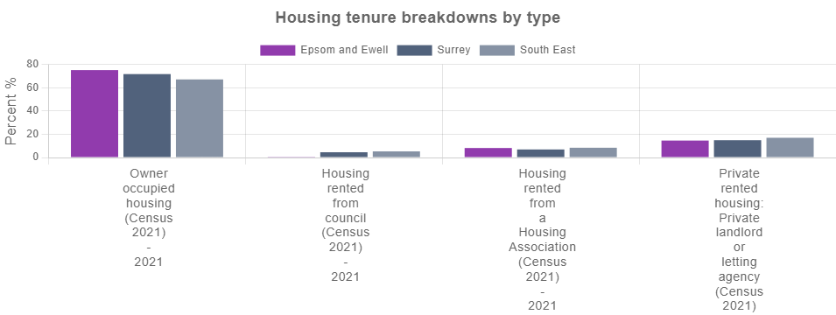
Source: UK Census

Crime
The information below shows the level of recorded crime in Epsom and Ewell and comparator areas. This is based on data for individual crime incidents published via the Police UK open data portal, which has been linked by Local Insight to selected neighbourhoods.
The table below shows counts and rates for the main crime types and anti-social behaviour incidents between Jun-2023 to May-2024.
There were 7,771 total crime offences in Epsom and Ewell between Jun-2023 to May-2024, with the overall crime rate being 95.7 per 1,000 population. This is similar to the average across Surrey (94.7) and lower than the average across South East (111.9).

Crime and Anti-Social Behaviour Incidents
Indicator | Epsom and Ewell |  | Surrey |  | South East
 | Count | Rate | Count | Rate | Count | Rate
Total crime offences (12 month total) (Jun-2023 to May-2024) | 7,771 | 95.7 | 114,979 | 94.7 | 1,049,380 | 111.9
Anti-social behaviour (12 month total) (Jun-2023 to May-2024) | 1,402 | 17.3 | 18,263 | 15.0 | 128,143 | 13.7
Bicycle theft offences (12 month total) (Jun-2023 to May-2024) | 156 | 1.9 | 1,579 | 1.3 | 12,929 | 1.4
Burglary (12 month total) (Jun-2023 to May-2024) | 326 | 10.4 | 4,519 | 9.4 | 39,183 | 10.3
Criminal damage (12 month total) (Jun-2023 to May-2024) | 548 | 6.8 | 9,156 | 7.5 | 89,259 | 9.5
Drug crime offences (12 month total) (Jun-2023 to May-2024) | 155 | 1.9 | 2,970 | 2.4 | 28,257 | 3.0
Other crime offences (12 month total) (Jun-2023 to May-2024) | 115 | 1.4 | 2,269 | 1.9 | 21,044 | 2.2
Other theft offences (12 month total) (Jun-2023 to May-2024) | 596 | 7.3 | 8,738 | 7.2 | 76,983 | 8.2
Shoplifting offences (12 month total) (Jun-2023 to May-2024) | 441 | 5.4 | 7,455 | 6.1 | 88,539 | 9.4
Possession of weapons offences (12 month total) (Jun-2023 to May-2024) | 61 | 0.8 | 936 | 0.8 | 11,315 | 1.2
Public order offences (12 month total) (Jun-2023 to May-2024) | 630 | 7.8 | 10,748 | 8.8 | 83,434 | 8.9
Robbery recorded offences (12 month total) (Jun-2023 to May-2024) | 61 | 0.8 | 657 | 0.5 | 7,022 | 0.7
Theft from the person offences (12 month total) (Jun-2023 to May-2024) | 48 | 0.6 | 646 | 0.5 | 9,244 | 1.0
Vehicle crime (12 month total) (Jun-2023 to May-2024) | 898 | 11.1 | 8,457 | 7.0 | 62,212 | 6.6
Violent crime and sexual offences (12 month total) (Jun-2023 to May-2024) | 2,334 | 28.7 | 38,586 | 31.8 | 391,815 | 41.8
Source: Police UK (Police recorded crime figures)

The line chart below shows a time series made up of 12 month totals of neighbourhood-level incidents of criminal offences. The figure is a rate per 1,000 residents. The first data point covers Sep-2018 to Aug-2019 and the final data point covers Jun-2023 to May-2024.
The overall crime rate in Epsom and Ewell has increased from 85.4 per 1,000 people between Sep-2018 to Aug-2019 to 95.7 per 1,000 people between Jun-2023 to May-2024.
Please note there can be missing data in Police.uk crime counts for certain areas. This is often due to issues with IT system changes at various police forces such as Devon and Cornwall, and Greater Manchester currently, which affects their reporting of figures to Police UK. Please see the Police UK change log for details of current known issues.

12 month total crime rate (time series)
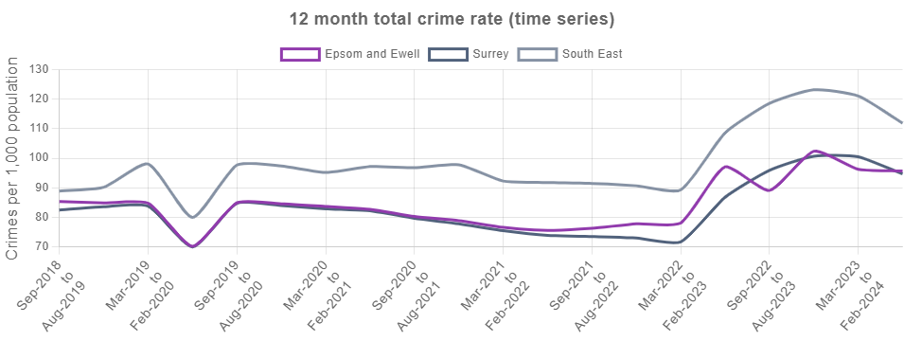
Source: Police UK

Health
The following data provides an overview of people's health with the first table below providing some key health statistics.
There are 3,825 people in Epsom and Ewell who are disabled under the equality act and whose day to day activities are limited a lot. This is 4.73% of the working population, which is lower than Surrey (5.14%) and lower than South East (6.26%).
In regards to the provision of unpaid care, there are 1,583 people in Epsom and Ewell providing 50+ hours of unpaid care a week. This is 2.07% of the working population, which is similar to Surrey (2.06%) and lower than South East (2.39%)

Key health statistics
Indicator | Epsom and Ewell |  | Surrey |  | South East
 | Count | Rate | Count | Rate | Count | Rate
Disabled under the Equality Act: Day-to-day activities limited a lot (Census 2021) (2021) | 3,825 | 4.73% | 61,835 | 5.14% | 581,048 | 6.26%
Disabled under the Equality Act: Day-to-day activities limited a little (Census 2021) (2021) | 6,544 | 8.09% | 104,266 | 8.67% | 915,292 | 9.87%
Not disabled under the Equality Act: Has long term physical or mental health condition but day-to-day activities are not limited (Census 2021) (2021) | 5,782 | 7.14% | 89,595 | 7.45% | 698,690 | 7.53%
Not disabled under the Equality Act: No long term physical or mental health conditions (Census 2021) (2021) | 64,787 | 80.05% | 947,410 | 78.75% | 7,083,035 | 76.34%
Very good health (Census 2021) (2021) | 43,925 | 54.27% | 649,544 | 53.99% | 4,636,748 | 49.98%
Good health (Census 2021) (2021) | 26,427 | 32.65% | 391,018 | 32.50% | 3,155,834 | 34.01%
Very bad health (Census 2021) (2021) | 536 | 0.66% | 9,000 | 0.75% | 86,139 | 0.93%
Bad health (Census 2021) (2021) | 1,940 | 2.40% | 31,378 | 2.61% | 307,131 | 3.31%
No unpaid care (Census 2021) (2021) | 70,302 | 92.12% | 1,046,976 | 92.04% | 8,049,399 | 91.65%
50+ hours unpaid care a week (Census 2021) (2021) | 1,583 | 2.07% | 23,469 | 2.06% | 209,863 | 2.39%
Children providing unpaid care (Census 2021) (2021) | 131 | 1.12% | 2,168 | 1.31% | 14,514 | 1.18%
Source: UK Census

The chart below shows the most recent number of Personal Independent Payment claimants.
A lower proportion of people in Epsom and Ewell are claiming Personal Independence Payment (4.59%) than in Surrey (4.85%) and a lower proportion than in South East (6.82%).

Personal Independence Payment (PIP) Claimants
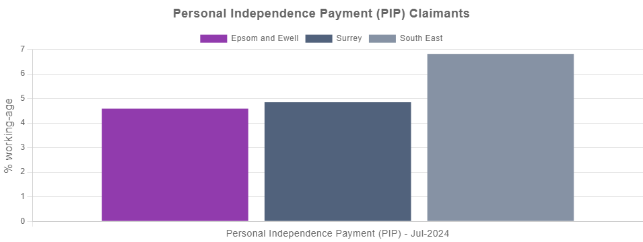
Source: Department for Work and Pensions (DWP)

Education
The following data is a summary of the key indicators related to education.
The table below shows the distribution of qualification levels and the subsequent bar chart shows a comparison of those with no qualifications besides those with degree level qualifications or higher.
There are 8,246 people in Epsom and Ewell with no qualifications, which is 12.76% of all people aged over 16. This is lower than the average for Surrey (12.86%) and lower than the average in South East (15.38%).
There are 28,642 people with degree level qualifications in Epsom and Ewell, which is 44.33% of people aged 16+. This is higher than the average in Surrey (42.36%) and higher than the average in South East (35.77%).

Level of qualification
Indicator | Epsom and Ewell |  | Surrey |  | South East
 | Count | Rate | Count | Rate | Count | Rate
People with no qualifications (Census 2021) (2021) | 8,246 | 12.76% | 125,027 | 12.86% | 1,162,221 | 15.38%
Highest level of qualification: Apprenticeship (Census 2021) (2021) | 2,628 | 4.07% | 40,761 | 4.19% | 386,759 | 5.12%
Highest level of qualification: Other qualifications (Census 2021) (2021) | 1,698 | 2.63% | 24,572 | 2.53% | 204,078 | 2.70%
Highest level of qualification: Level 1 qualifications (Census 2021) (2021) | 5,106 | 7.90% | 82,079 | 8.44% | 739,122 | 9.78%
Highest level of qualification: Level 2 qualifications (Census 2021) (2021) | 8,177 | 12.66% | 127,462 | 13.11% | 1,046,800 | 13.86%
Highest level of qualification: Level 3 qualifications (Census 2021) (2021) | 10,110 | 15.65% | 160,632 | 16.52% | 1,313,552 | 17.39%
Highest level of qualification: Level 4/5 (degree or higher) qualifications (Census 2021) (2021) | 28,642 | 44.33% | 411,979 | 42.36% | 2,702,048 | 35.77%
Source: UK Census

No qualifications or degree level and above
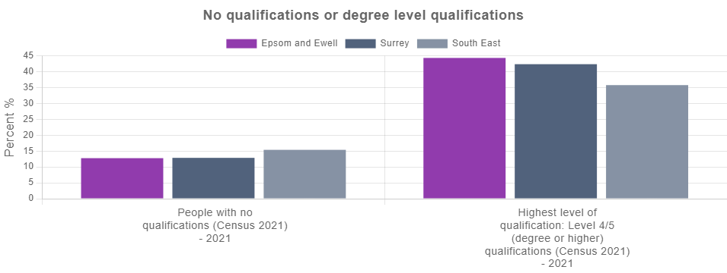
Source: UK Census

Employment
The following data is a summary of key indicators related to employment.
The table below shows figures for the number of people that hold either full or part-time roles alongside the figures for those working in either the public or private sectors.
A higher proportion of people in Epsom and Ewell work in the private sector (80.95%) than the public sector (19.05%). People are more likely to be part-time employed in Epsom and Ewell (38.71%) than in Surrey (32.81%) and more likely than in South East (31.67%).

Jobs by type
Indicator | Epsom and Ewell | Surrey | South East
Full-time employees (2022) | 61.29% | 67.19% | 68.33%
Part-time employees (2022) | 38.71% | 32.81% | 31.67%
Public sector employees (2022) | 19.05% | 12.72% | 15.10%
Private sector employees (2022) | 80.95% | 87.28% | 84.90%
Source: Business Register and Employment Survey (BRES)

The jobs density (calculated as the number of jobs per 100 working-age people) in Epsom and Ewell was 62.24% in 2022. This is lower than the average across Surrey (78.60%) and lower than the average across South East (76.16%).

Jobs density
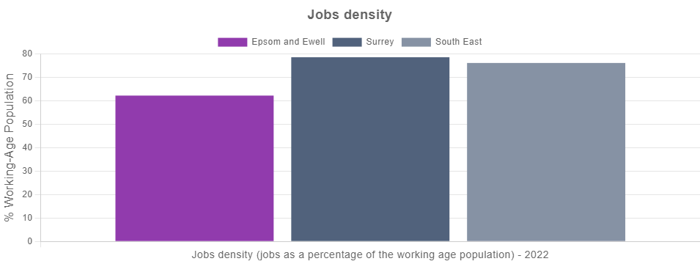
Source: Business Register and Employment Survey (BRES)

Communities and Environment
The following data is a summary of key indicators related to the community and environment.
The first chart below shows the overall rank on the 2023 Community Needs Index (CNI), as well as a rank on each of the three CNI domains for Epsom and Ewell, Surrey and South East.
The CNI was developed to identify areas experiencing poor community and civic infrastructure, relative isolation and low levels of participation in community life. The index was created by combining a series of 28 indicators, conceptualised under three domains: Civic Assets, Connectedness and Active and Engaged Community. A lower rank indicates that an area has relatively higher levels of need.
- Civic Assets: measures the presence of key community, civic, educational and cultural assets in a close proximity of the area. These include pubs, libraries, green space, community centres, swimming pools – facilities that provide things to do often, at no or little cost, which are important to how positive a community feels about its area.
- Connectedness: measures the connectivity to key services, digital infrastructure, isolation and strength of the local jobs market. It looks at whether residents have access to key services, such as health services, within a reasonable travel distance. It considers how good public transport and digital infrastructure are and how strong the local job market is.
- Active and Engaged Community: measures the levels of third sector civic and community activity and barriers to participation and engagement. It shows whether charities are active in the area, and whether people appear to be engaged in the broader civic life of their community.
Epsom and Ewell has an overall CNI rank of 27,865. This means that Epsom and Ewell has lower levels of community need than Surrey (23,790) and lower levels of community need than South East (17,783).

CNI Rank
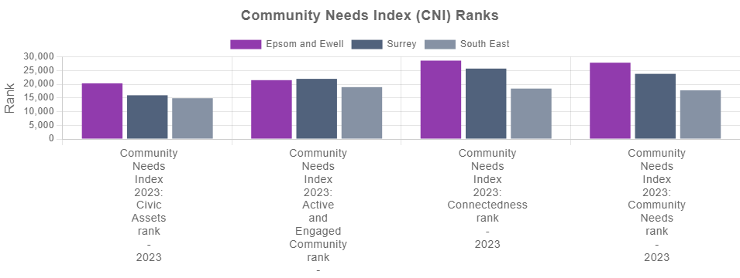
Source: Oxford Consultants for Social Inclusion (OCSI)

The table below shows the Indices of Deprivation Air Quality Measures. For each pollutant the atmospheric concentration was compared to a national standard value, with the concentrations in each Lower-layer Super Output Area divided by the appropriate national standard, before summing to produce a single indicator. A higher score indicates that an area is experiencing relatively higher levels of deprivation.
Based on the IoD 2019 Air quality indicator - Epsom and Ewell has higher levels of air pollution (1.070 IoD score) than Surrey (0.982 IoD score) and higher levels of air pollution than South East (0.946 IoD score).

Indices of Deprivation Air Quality Measures
Indicator | Epsom and Ewell | Surrey | South East
IoD 2019 Air quality indicator (2016) | 1.070 | 0.982 | 0.946
IoD 2019 Benzene (component of air quality indicator) (2016) | 0.129 | 0.105 | 0.108
IoD 2019 Nitrogen dioxide (component of air quality indicator) (2016) | 0.462 | 0.431 | 0.397
IoD 2019 Particulates (component of air quality indicator) (2016) | 0.449 | 0.419 | 0.411
IoD 2019 Sulphur dioxide (component of air quality indicator) (2016) | 0.028 | 0.028 | 0.030
IoD 2019 Road traffic accidents indicator (2015 to 2016) | 0.508 | 0.901 | 0.756
Source: Ministry of Housing Communities and Local Government (MHCLG)

Access and Transport
The following data is a summary of the main access and transport related indicators.
The table below shows the proportion of households according to their ownership of a car or van. This is based on responses to the car ownership question in the 2021 Census which asks information on the number of cars or vans owned, or are available for use, by one or more members of a household. This includes company cars and vans available for private use and is based on details for private households only. Cars or vans used by residents of communal establishments are not counted.
In Epsom and Ewell, 14.26% of households have no access to a car or van. This is greater than the proportion without access to a car or van in Surrey (12.71%) and less than the proportion without access to a car or van in South East (16.86%).

Car or van ownership
Indicator | Epsom and Ewell | Surrey | South East
Households with no car (Census 2021) (2021) | 14.26% | 12.71% | 16.86%
1 car or van in household (Census 2021) (2021) | 45.24% | 40.43% | 40.81%
2 cars or vans in household (Census 2021) (2021) | 29.92% | 33.20% | 30.55%
Households with 3+ cars (Census 2021) (2021) | 10.58% | 13.65% | 11.78%
Source: UK Census

The bar chart below shows the proportion of households with no car or van in the 2021 Census alongside the proportions from previous Censuses to identify changes over time.
In 2011, 14.40% of households in Epsom and Ewell had no access to a car or van. This is similar to the proportion without access to a car or van in 2021 (14.26%).

Households with no car or van
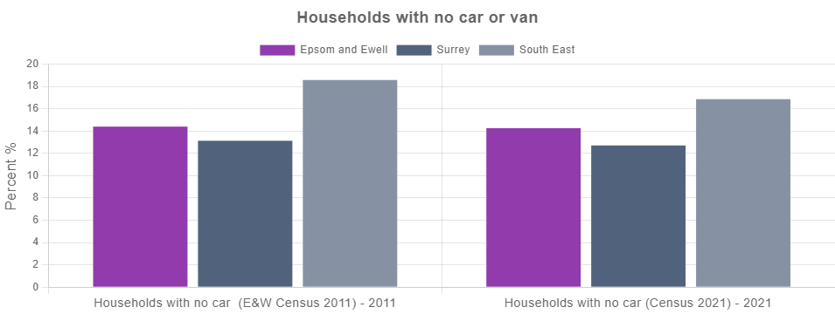
Source: UK Census

Appendix: Data sources

Theme | Data | Data source / time period
Population | All people (Census 2021) | Census 2021 (2021)
Population | All Females (Census 2021) | Census 2021 (2021)
Population | All Males (Census 2021) | Census 2021 (2021)
Population | Population aged under 16 (Census 2021) | Census 2021 (2021)
Population | Population aged 16 to 64 (Census 2021) | Census 2021 (2021)
Population | Population aged 65+ (Census 2021) | Census 2021 (2021)
Population | Population Density (Persons per sq km) (Census 2021) | Census 2021 (2021)
Population | Index of Multiple Deprivation 2019 (IMD) Score | Ministry of Housing Communities and Local Government (MHCLG) (2019)
Population | Index of Multiple Deprivation (IMD) 2019 Rank | Ministry of Housing Communities and Local Government (MHCLG) (2019)
Population | IMD 2019 Decile 1 | Communities and Local Government (CLG) (2019)
Population | IMD 2019 Decile 2 | Communities and Local Government (CLG) (2019)
Population | IMD 2019 Decile 3 | Communities and Local Government (CLG) (2019)
Population | IMD 2019 Decile 4 | Communities and Local Government (CLG) (2019)
Population | IMD 2019 Decile 5 | Communities and Local Government (CLG) (2019)
Population | IMD 2019 Decile 6 | Communities and Local Government (CLG) (2019)
Population | IMD 2019 Decile 7 | Communities and Local Government (CLG) (2019)
Population | IMD 2019 Decile 8 | Communities and Local Government (CLG) (2019)
Population | IMD 2019 Decile 9 | Communities and Local Government (CLG) (2019)
Population | IMD 2019 Decile 10 | Communities and Local Government (CLG) (2019)
Unemployment | Unemployment benefit claimants (Jobseekers Allowance and out of work Universal Credit claimants) | Department for Work and Pensions (DWP) (Aug-2024)
Unemployment | Youth unemployment (18-24 receiving JSA or Universal Credit) | Department for Work and Pensions (DWP) (Aug-2024)
Unemployment | Older person unemployment (50+ receiving JSA or Universal Credit) | Department for Work and Pensions (DWP) (Aug-2024)
Unemployment | Unemployment benefit (JSA and Universal Credit), female | Department for Work and Pensions (DWP) (Aug-2024)
Unemployment | Unemployment benefit (JSA and Universal Credit), male | Department for Work and Pensions (DWP) (Aug-2024)
Unemployment | Unemployment benefit claimants (Jobseekers Allowance and out of work Universal Credit claimants) | Department for Work and Pensions (DWP) (Jan-2020)
Housing | Average house price (12 months) | Land Registry (Jun-2023 to May-2024)
Housing | Average house price for detached houses (12 months) | Land Registry (Jun-2023 to May-2024)
Housing | Average house price for flats (12 months) | Land Registry (Jun-2023 to May-2024)
Housing | Average house price for semi-detached houses (12 months) | Land Registry (Jun-2023 to May-2024)
Housing | Average house price for terraced houses (12 months) | Land Registry (Jun-2023 to May-2024)
Housing | Owner occupied housing (Census 2021) | Census 2021 (2021)
Housing | Housing rented from council (Census 2021) | Census 2021 (2021)
Housing | Housing rented from a Housing Association (Census 2021) | Census 2021 (2021)
Housing | Private rented housing: Private landlord or letting agency (Census 2021) | Census 2021 (2021)
Crime | Total crime offences (12 month total) | Police UK (Jun-2023 to May-2024)
Crime | Anti-social behaviour (12 month total) | Police UK (Jun-2023 to May-2024)
Crime | Bicycle theft offences (12 month total) | Police UK (Jun-2023 to May-2024)
Crime | Burglary (12 month total) | Police UK (Jun-2023 to May-2024)
Crime | Criminal damage (12 month total) | Police UK (Jun-2023 to May-2024)
Crime | Drug crime offences (12 month total) | Police UK (Jun-2023 to May-2024)
Crime | Other crime offences (12 month total) | Police UK (Jun-2023 to May-2024)
Crime | Other theft offences (12 month total) | Police UK (Jun-2023 to May-2024)
Crime | Shoplifting offences (12 month total) | Police UK (Jun-2023 to May-2024)
Crime | Possession of weapons offences (12 month total) | Police UK (Jun-2023 to May-2024)
Crime | Public order offences (12 month total) | Police UK (Jun-2023 to May-2024)
Crime | Robbery recorded offences (12 month total) | Police UK (Jun-2023 to May-2024)
Crime | Theft from the person offences (12 month total) | Police UK (Jun-2023 to May-2024)
Crime | Vehicle crime (12 month total) | Police UK (Jun-2023 to May-2024)
Crime | Violent crime and sexual offences (12 month total) | Police UK (Jun-2023 to May-2024)
Crime | Total crime offences (12 month total) | Police UK (Sep-2018 to Aug-2019)
Health | Disabled under the Equality Act: Day-to-day activities limited a lot (Census 2021) | Census 2021 (2021)
Health | Disabled under the Equality Act: Day-to-day activities limited a little (Census 2021) | Census 2021 (2021)
Health | Not disabled under the Equality Act: Has long term physical or mental health condition but day-to-day activities are not limited (Census 2021) | Census 2021 (2021)
Health | Not disabled under the Equality Act: No long term physical or mental health conditions (Census 2021) | Census 2021 (2021)
Health | Very good health (Census 2021) | Census 2021 (2021)
Health | Good health (Census 2021) | Census 2021 (2021)
Health | Very bad health (Census 2021) | Census 2021 (2021)
Health | Bad health (Census 2021) | Census 2021 (2021)
Health | No unpaid care (Census 2021) | Census 2021 (2021)
Health | 50+ hours unpaid care a week (Census 2021) | Census 2021 (2021)
Health | Children providing unpaid care (Census 2021) | Census 2021 (2021)
Health | Personal Independence Payment (PIP) | Department for Work and Pensions (DWP) (Jul-2024)
Education | People with no qualifications (Census 2021) | Census 2021 (2021)
Education | Highest level of qualification: Apprenticeship (Census 2021) | Census 2021 (2021)
Education | Highest level of qualification: Other qualifications (Census 2021) | Census 2021 (2021)
Education | Highest level of qualification: Level 1 qualifications (Census 2021) | Census 2021 (2021)
Education | Highest level of qualification: Level 2 qualifications (Census 2021) | Census 2021 (2021)
Education | Highest level of qualification: Level 3 qualifications (Census 2021) | Census 2021 (2021)
Education | Highest level of qualification: Level 4/5 (degree or higher) qualifications (Census 2021) | Census 2021 (2021)
Education | People with no qualifications (Census 2021) | Census 2021 (2021)
Education | Highest level of qualification: Level 4/5 (degree or higher) qualifications (Census 2021) | Census 2021 (2021)
Employment | Full-time employees | Business Register and Employment Survey (BRES) (2022)
Employment | Part-time employees | Business Register and Employment Survey (BRES) (2022)
Employment | Public sector employees | Business Register and Employment Survey (BRES) (2022)
Employment | Private sector employees | Business Register and Employment Survey (BRES) (2022)
Employment | Jobs density (jobs as a percentage of the working age population) | Business Register and Employment Survey (BRES) (2022)
Communities and Environment | Community Needs Index 2023: Civic Assets rank | Oxford Consultants for Social Inclusion (OCSI) (2023)
Communities and Environment | Community Needs Index 2023: Active and Engaged Community rank | Oxford Consultants for Social Inclusion (OCSI) and Local Trust (2023)
Communities and Environment | Community Needs Index 2023: Connectedness rank | Oxford Consultants for Social Inclusion (OCSI) (2023)
Communities and Environment | Community Needs Index 2023: Community Needs rank | Oxford Consultants for Social Inclusion (OCSI) (2023)
Communities and Environment | IoD 2019 Air quality indicator | Ministry of Housing Communities and Local Government (MHCLG) (2016)
Communities and Environment | IoD 2019 Benzene (component of air quality indicator) | Ministry of Housing Communities and Local Government (MHCLG) (2016)
Communities and Environment | IoD 2019 Nitrogen dioxide (component of air quality indicator) | Ministry of Housing Communities and Local Government (MHCLG) (2016)
Communities and Environment | IoD 2019 Particulates (component of air quality indicator) | Ministry of Housing Communities and Local Government (MHCLG) (2016)
Communities and Environment | IoD 2019 Sulphur dioxide (component of air quality indicator) | Ministry of Housing Communities and Local Government (MHCLG) (2016)
Communities and Environment | IoD 2019 Road traffic accidents indicator | Ministry of Housing Communities and Local Government (MHCLG) (2015 to 2016)
Access and Transport | Households with no car (Census 2021) | Census 2021 (2021)
Access and Transport | 1 car or van in household (Census 2021) | Census 2021 (2021)
Access and Transport | 2 cars or vans in household (Census 2021) | Census 2021 (2021)
Access and Transport | Households with 3+ cars (Census 2021) | Census 2021 (2021)
Access and Transport | Households with no car (E&W Census 2011) | Census 2011 (2011)
Access and Transport | Households with no car (Census 2021) | Census 2021 (2021)

